# Decision Tree Assignment

## Project 1: *Build Decision Tree(DV-"Survived",IDV-"Age,Gender and Fare") and Predict it.*

* **Finding the Important features using Random Forest algorithm:**

The important features are:

* Gender
* Age
* Fare

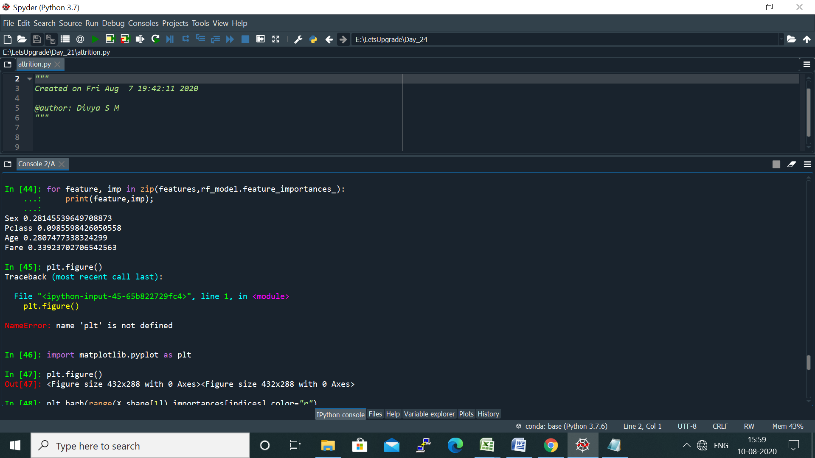

* **Finding the accuracy of the model:**

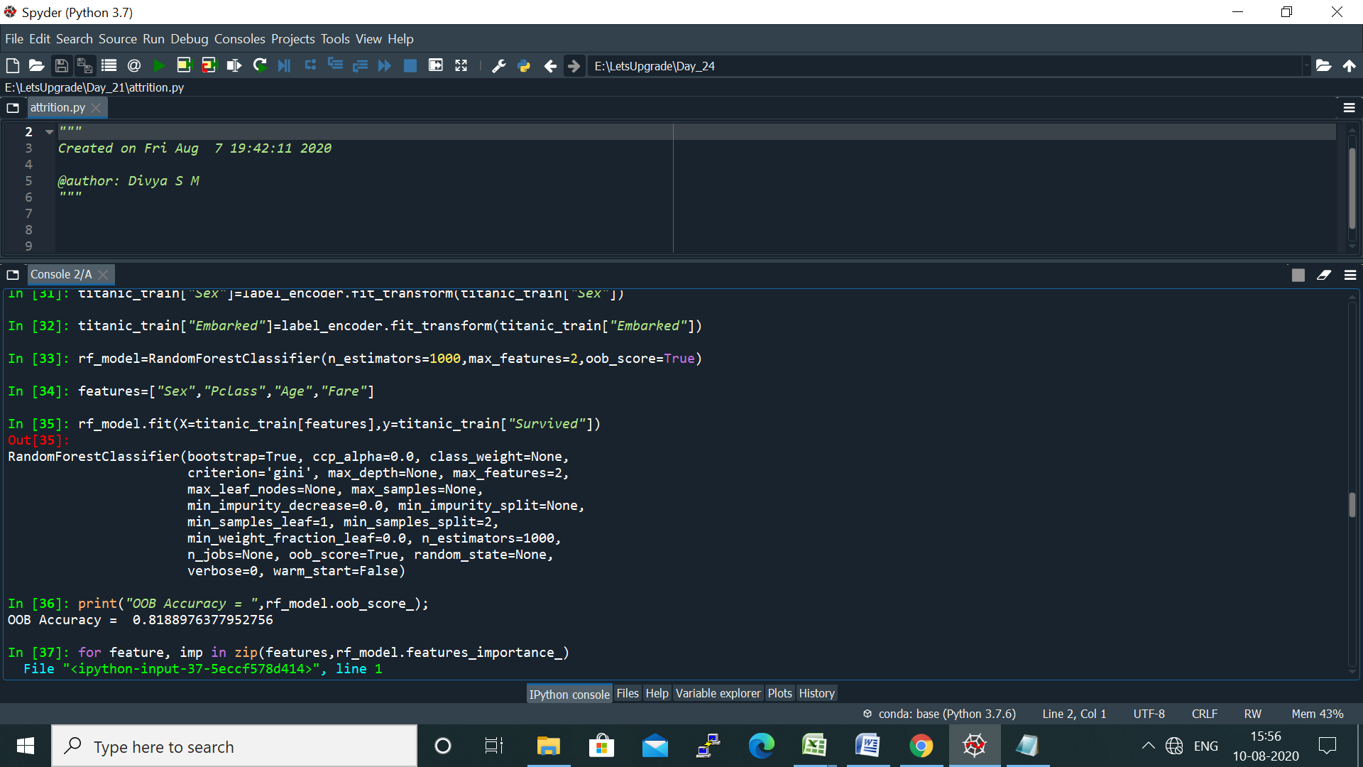

OOB Accuracy value is 0.8188 which is approx. 82% is the model accuracy.

* **Decision Tree for the model:**

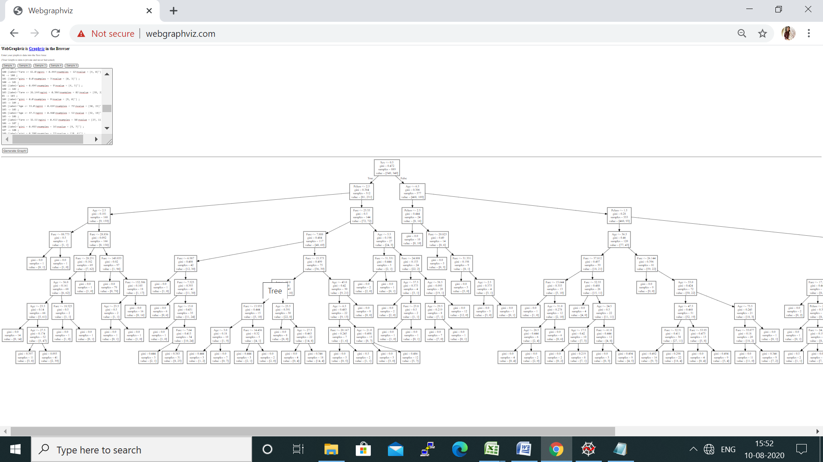

*****************************************************************************

## Project 2: *Build Decision Tree for Attrition Rate Analysis*

* **Finding the Important features using Random Forest algorithm :**

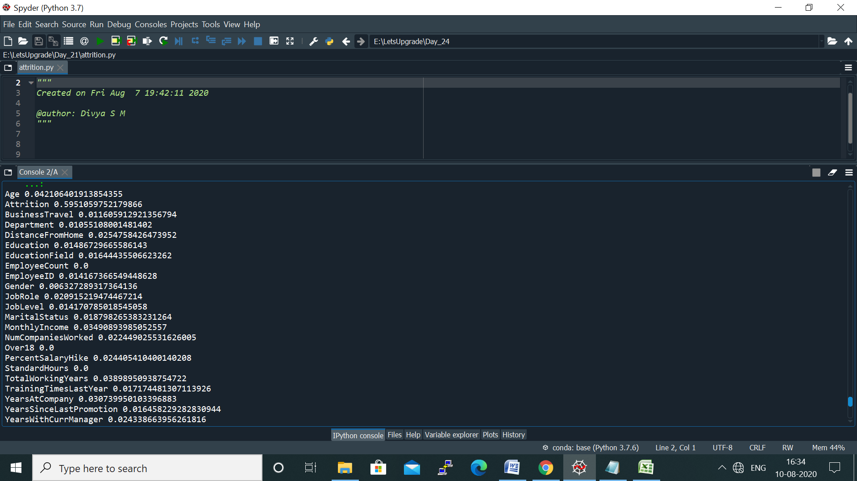

Important features are:

* Age
* Monthly Income
* Total Working Years
* Years At Company
* **Model Accuracy:**

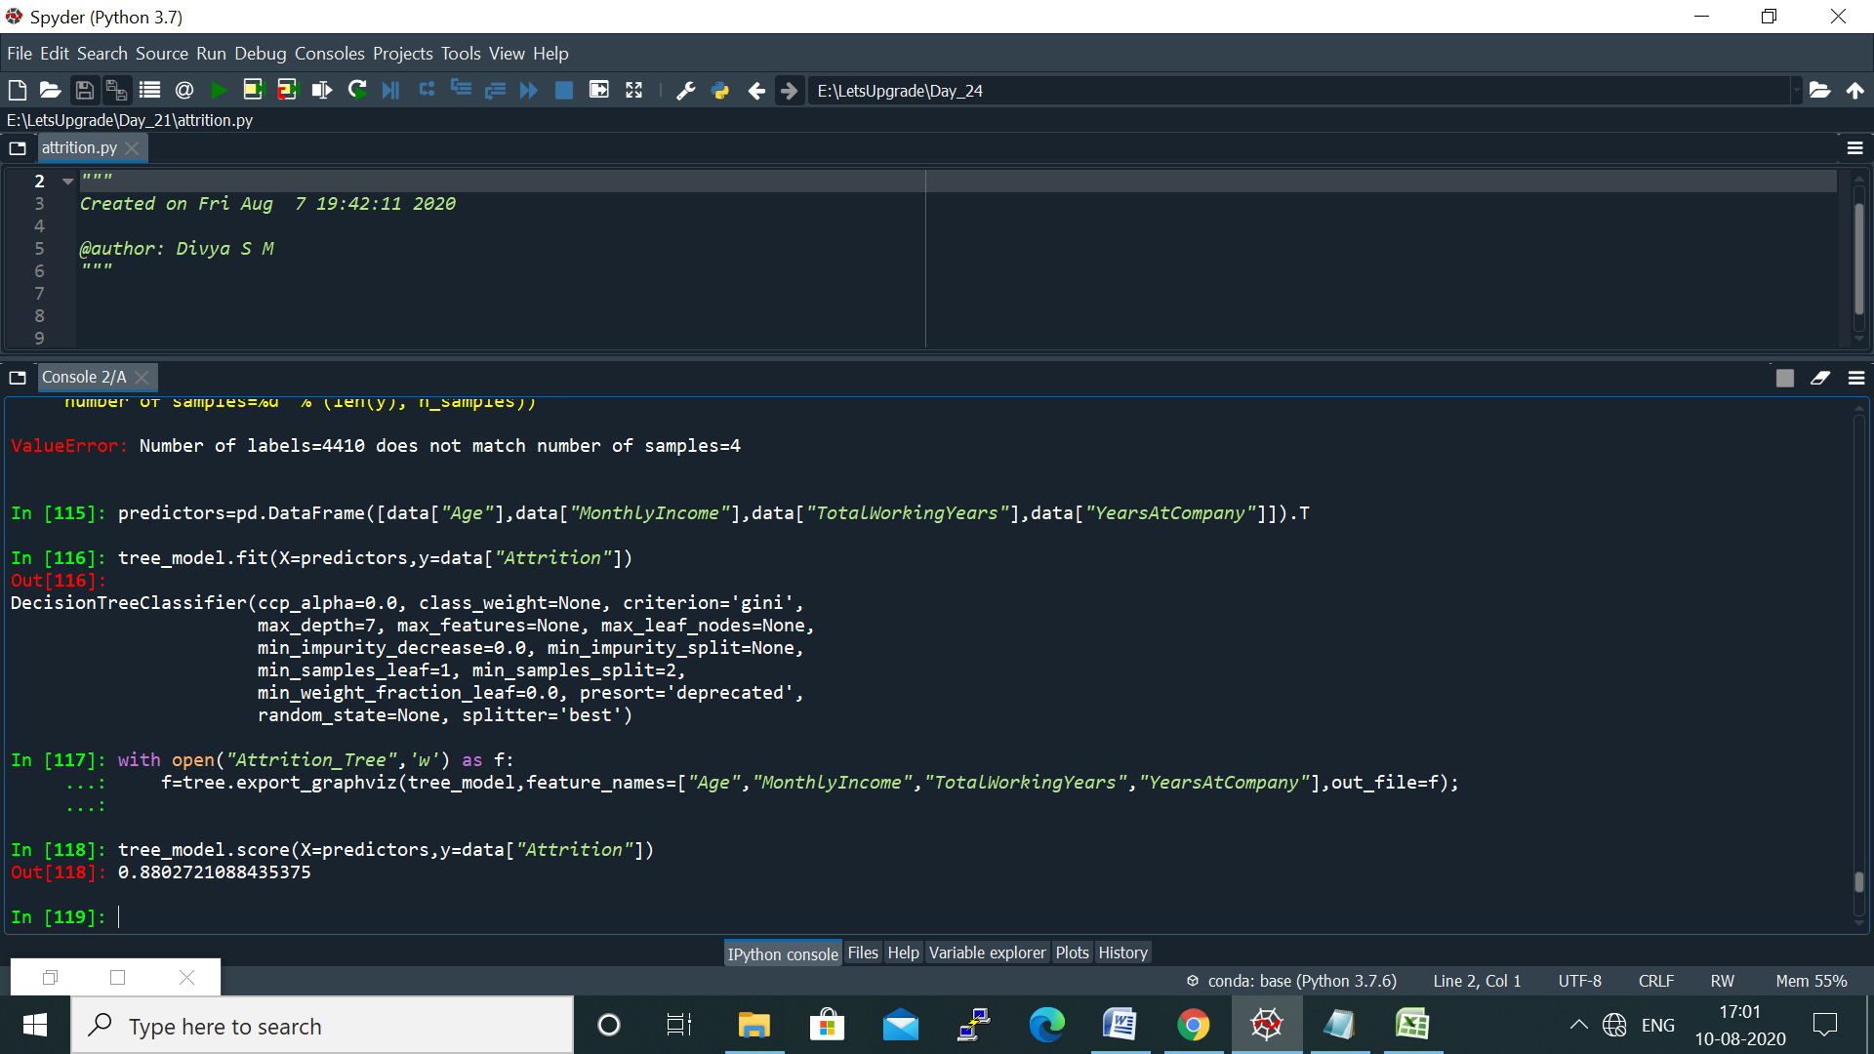

The model is 88% accurate.

* **Decision Tree for the Model:**

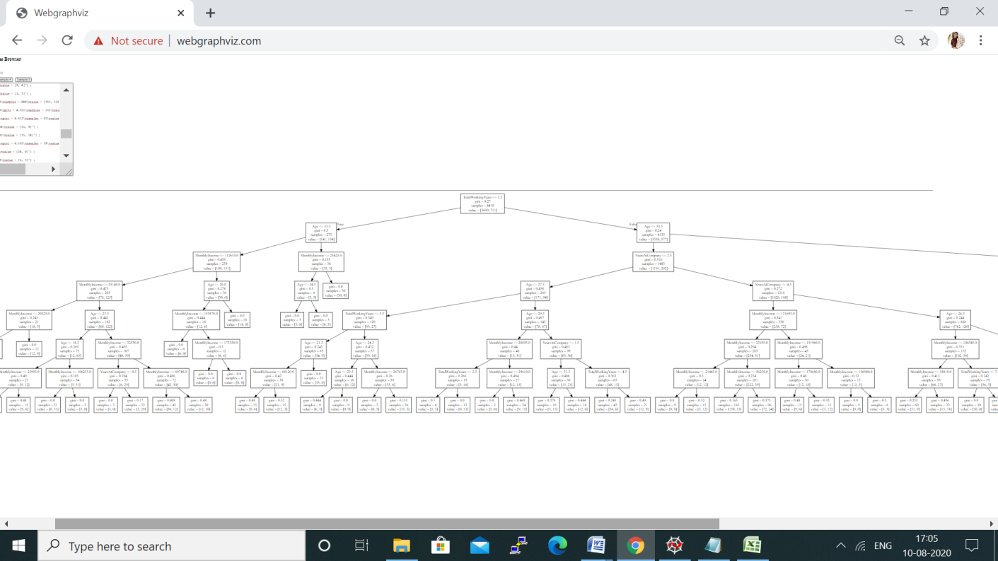

******************************************************************

## Project 3: Build Decision Tree for Bank Loan Modeling

* **Finding the Important features using Random Forest algorithm :**

The important features are:

* Income
* CCAvg
* Income

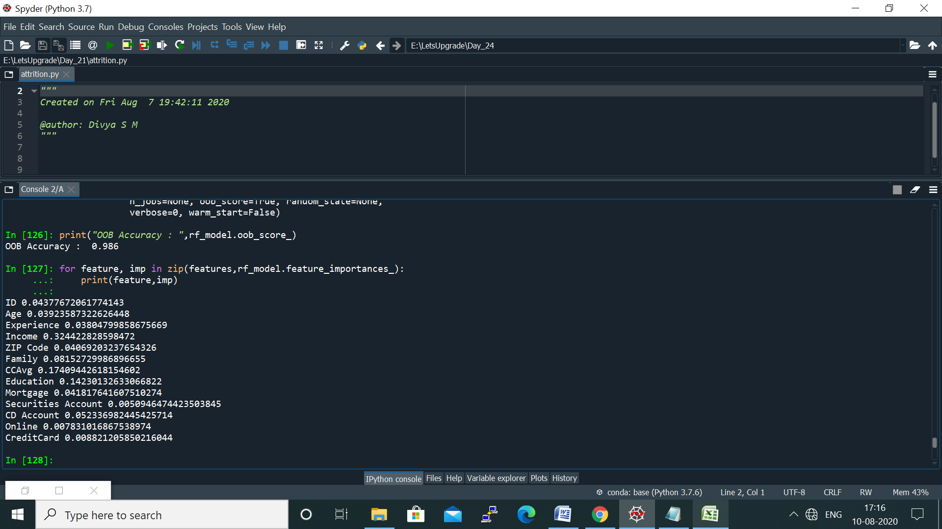

* **Model Accuracy:**

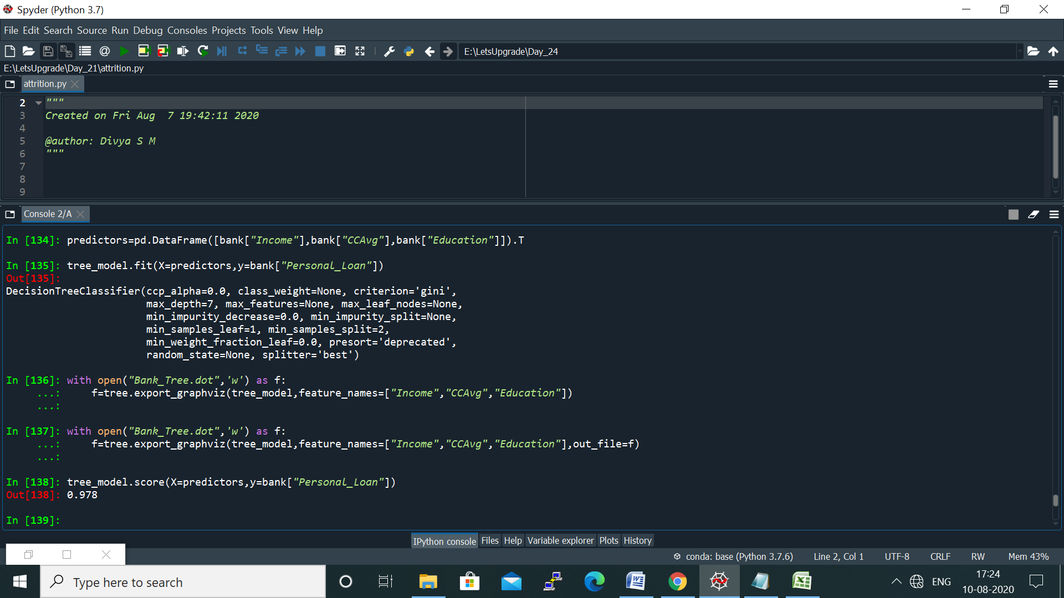

The model is 97.8% accurate.

* **Decision Tree for the model:**

